Pokhara University

Level: Bachelor | Semester – Spring | Year : 2005
Programme: BE |  | Full Marks: 100
Course: Engineering Mathematics III |  | Time : 3hrs.

Candidates are required to give their answers in their own words as far as practicable.
The figures in the margin indicate full marks.

Attempt all the questions.

 | - show that 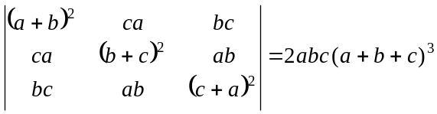  - Define rank of a matrix. Find the rank of the matrix. 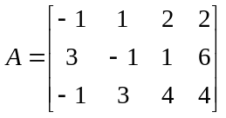 | 8  7
 | - Define consistence and inconsistence of a system of linear equations. Solve the given system of equations by using Gauss elimination method.  x + y + z = 8  x – 2y + z = 6  3x + 5y –7z = 14  - Define eigen values and vectors of a matrix. Find eigen values and vectors of A = 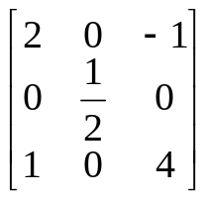  OR  Define vector subspace of a vector space. If V = R³ be a vector space and W = {(x, y, z); x + 2y + 3z = 0} show that W is a vector subspace of V. | 8  7
 | - Let f be a continuous and differentiable scalar valued function, then show that curl (grad f) = 0. Find unit normal on the surface 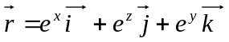 at (2, 3, 4).  - Define directional derivative. If 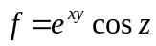, find the directional derivative at the point (1,2,2) along the vector 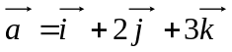 | 8  7
 | - if 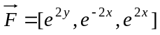, S; the surface given by position vector  - Define surface integral of 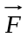on the surface S. Evaluate 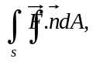where 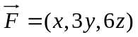and S is the surface of the cone 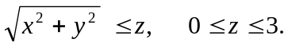 | 8  7
 | - Show the product of two odd functions is even function. Find the Fourier series expansion of f(x).  If 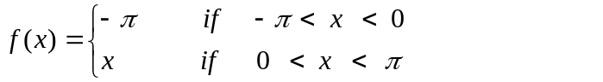  - Express f(x) = x as the half range series cosine series in 0 < x < 2. | 8  7
 | - Test the convergence of  - 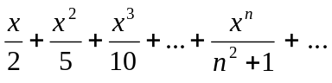  - 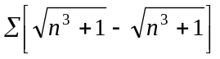  - Find interval of convergence of an infinite series 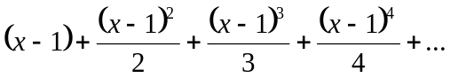  OR  Use Maclaurin's theorem to find the expansion of f(x) = tanx in  ascending power of x and hence find the expansion of sec²x . | 8  7
 | Attempt all:  - Test the divergence for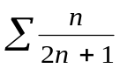.  - Evaluate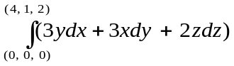.  - If 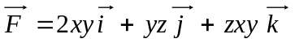. Find curl (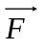).  - Find smallest period of f(x) =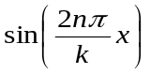.  - Examine whether 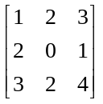 is a singular matrix? | 2  2  2  2  2

